Send an e-mail Attachment (MS Office 2003)
- In Word (or Excel, PowerPoint) Save the document you will send/attach.
  - Use File > SAVE AS... so that you can see and note the name of the document and the drive and folder (and subfolders if any). You’ll need to be able to navigate to it later.
- If you need to see more of the path, click on the arrow next to the Save in: field. It will drop down the screen pictured below which displays the drive, folder and subfolders as indented icons.

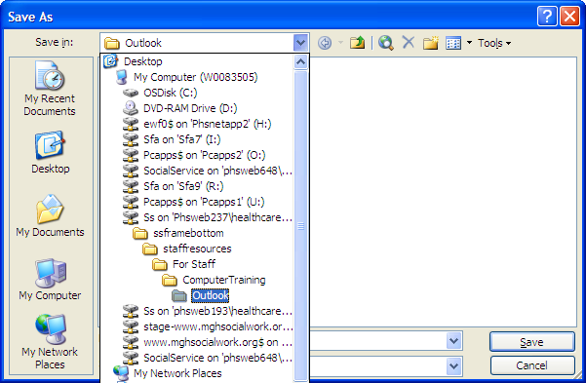
Click here to display this drop-down
- In Outlook open a new e-mail message and select Insert > File, or click the paperclip button 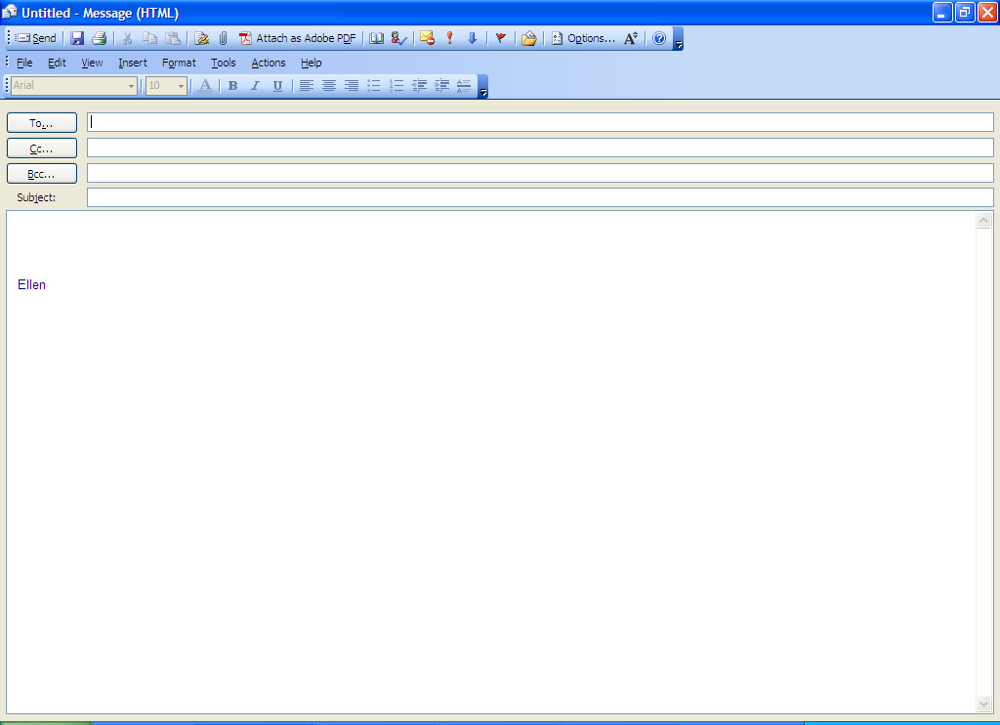 at the top of the screen.
- This will open the Insert File dialogue box. It looks very similar to the Save As... dialogue box that you just visited, pictured above.

(See next page)

The Insert File Dialogue Box 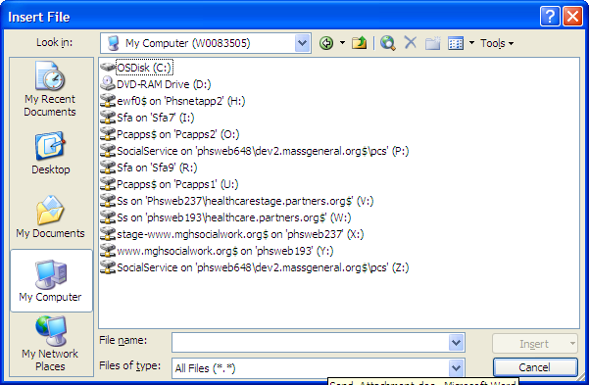

- Navigate to the desired document using the drop-down menu next to the “Look in” field as you did above.
  - Double click on the desired drive and repeat on the folders and any subfolders until you can see the name of the desired document.
- Double-click on the desired document. It will now appear in the message body. Add text to your subject line and any message and signature and send the e-mail.

