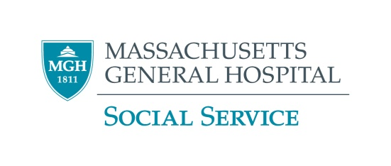

**Relapse Prevention Counseling**

**What is relapse prevention counseling?**

We often recommend relapse prevention counseling for people who have had problems in the past because of their alcohol or drug use. This form of counseling can help you reflect on your history of substance use and strengthen your coping skills when facing situations that may have triggered you to use alcohol or drugs in the past. It is also an opportunity for you to learn more about addiction and the challenges to expect when maintaining long-term sobriety. This is an outpatient, one-on-one treatment.

**Who can provide these services?**

Specially trained licensed social workers, mental health counselors, psychologists, and alcohol and drug counselors can provide these services in the community.

**How do I find a provider?**

* Call the number on the back of your insurance card to find a covered provider.
* Talk to your primary care physician (PCP) about a referral to a local provider.
* Call a provider directly.
* Below are some resources that may help you find providers in your area.

**Questions to ask**

* Do you have a background in substance abuse?
* Are you accepting new patients?

**Find a provider**

* **Psychology Today Therapist Finder**

<https://therapists.psychologytoday.com/rms/>

Search using zip code, insurance, and specify “addiction”

* **Massachusetts Substance Abuse Information and Education Helpline**

1-800-327-5050

[www.helpline-online.com](http://www.helpline-online.com)

* **Substance Abuse and Mental Health Services Administration**

1-800-662-4357

[www.samhsa.gov](http://www.samhsa.gov)

* **Social Work Therapy Referral Service**

617-720-2828 or 1-800-242-9794

[info@therapymatcher.org](mailto:info@therapymatcher.org)