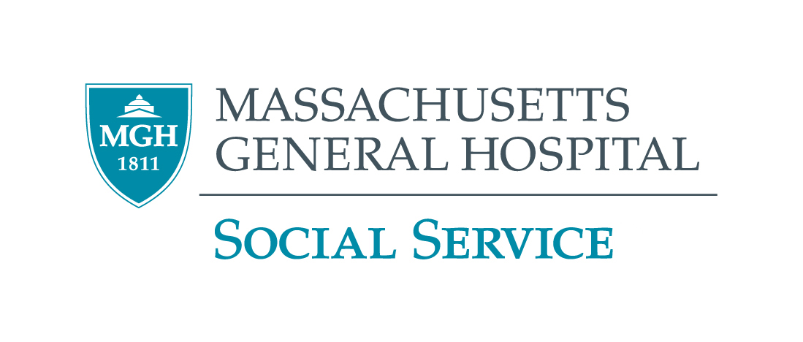

2021 – 2022 GRAND ROUNDS PROGRAM
MGH Virtual Event Until Further Notice

September 9, 2021  Thursday  10:00 – 11:30 a.m. | Dr. Richard Cabot, Ida Cannon, and Medical Social Work at Mass. General Hospital  Laura Praglin, M.A., M.A.R., Ph.D.  Dr. Laura Praglin is Professor Emerita of Social Work at the University of Northern Iowa. Her professional publications include articles related to the history of medical social service and to the relationship of spirituality to social work theory and practice.
October 21, 2021  Thursday  10:00 – 11:30 a.m. | Addressing Microaggressions in Mental Health Care: Increasing Awareness and Skills  Ashley Davis, MSW, Ph.D., Makieya Kamara, MSW, MSN & Nicole Ivone, MSW, MNL  Ashley Davis is a Clinical Associate Professor at the Boston University School of Social Work, where she teaches courses on clinical practice and social work research. Makieya Kamara is a social worker who works at Action for Boston Community Development, where she manages a civic engagement program for older adults. Nicole Ivone is an Equal Opportunity Specialist with the New Hampshire National Guard, where she facilitates cultural competence training and evaluates the health and welfare of the organizational culture.
November 11, 2021  Thursday  10:00 – 11:30 a.m. | African American Women/Girls and Depression  Crystal Carter, APSW, LCSW  Crystal is currently a Clinical Assistant Professor/Field Liaison at the University of Wisconsin-Milwaukee, where she is responsible for teaching field seminars and overseeing field placements for master-level students in community based-mental health and substance abuse treatment programs, outpatient clinics, and veteran’s services.
December 9, 2021  Thursday  10:00 – 11:30 a.m. | Mental Health Inequities in Black and Latinx Low Income Communities  Michelle Durham, MD, MPH  Dr. Michelle Durham is the Vice Chair of Education in the Department of Psychiatry at Boston University School of Medicine /Boston Medical Center. She is a board-certified physician specializing in pediatric and adult psychiatry with additional board certification in addiction medicine.
January 20, 2022  Thursday  10:00 – 11:30 a.m. | Neighborhood and Housing as Social Determinants of Mental Health  Mariana Arcaya, ScD, MCP  Dr. Mariana Arcaya's work is at the intersection of public health and urban planning, she explores dynamic relationships between place and health.
February 17, 2022  Thursday  10:00 – 11:30 a.m. | The Criminal Justice System: Racism, Carceral Capitalism and Humanism  Daniel Foley and Diana Saintil, B.A., Ed.M.  Daniel Foley is a Recovery Coach/Peer Navigator at MGH. Diana Saintil is an educator by love and believes that education is an emancipatory tool that can transform individuals, families, and communities.
March 10, 2022  Thursday  10:00 – 11:30 a.m. | Strategies used by older Latinx Immigrants to Effectively Engage with the Health Care System  Rocío Calvo, Ph.D.  Dr. Rocío Calvo’s research focuses on understanding the personal, community, and structural factors that facilitate Latinx immigrants’ access to social services, including health care.
April 21, 2022  Thursday  10:00 – 11:30 a.m. | Police Reform: Community Action to Improve Emergency Response to Mental Health Crises in Boston  Brian Corr, B.A  Brian Corr has worked for the City of Cambridge as Executive Director of the Police Review & Advisory Board since September 2010, and as Executive Director of the city's Peace Commission since 2008.
May 19, 2022  Thursday  10:00 – 11:30 a.m. | Sociocultural Considerations in Assessment of Brain Disorders  Yakeel Quiroz, Ph.D and Paula Aduen, Ph.D.  Dr. Yakeel Quiroz is Associate Professor in the Departments of Psychiatry and Neurology at MGH and Harvard Medical School. Dr. Paula Aduen, Ph.D. is the Assistant Director of the Multicultural Assessment and Research Center at MGH.
June 16, 2022  Thursday  10:00 – 11:30 a.m. | Tentative
CEU’s Only available for Social Workers Call (617) 724-0759 for more information ALL STAFF WELCOME

