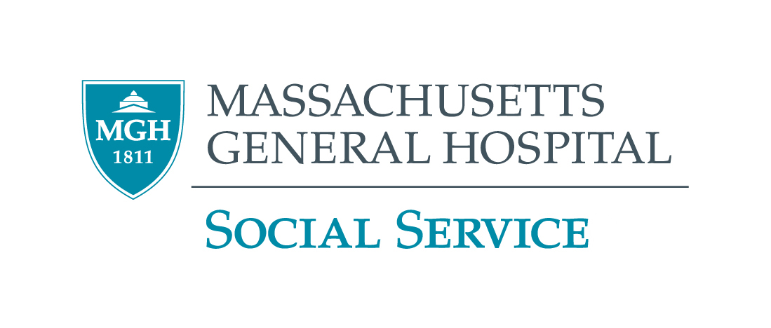

2022 – 2023 GRAND ROUNDS PROGRAM
MGH Virtual Event Until Further Notice

September 15, 2022  Thursday  10:00 – 11:30 a.m. | Refugee and Asylees – Legal and Medical Issues  Fernando Chang-Muy, B.A., M.A., J.D.  Fernando Chang-Muy is a lawyer, activist, academic, and leadership consultant. He is the Thomas O'Boyle Lecturer in Law at the University of Pennsylvania where he teaches courses on US. Immigration, International Human Rights and Refugee Policy, and Principles of Nonprofit leadership.
October 20, 2022  Thursday  10:00 – 11:30 a.m. | Forensic Medical Evaluations of Asylum-Seekers in a Time of Unprecedented Global Displacement and Migration  Matthew Gartland, M.D., Kara Huselton, LICSW, Altaf Saadi, M.D.  Dr. Matthew Gartland is an Internist and Pediatrician, and the Director of the MGH Asylum Clinic at the MGH Center for Global Health. Kara Huselton is a Community Resource Navigator Manager at MGH and a volunteer with the MGH Asylum Clinic. Dr. Altaf Saadi is a Neurologist at MGH Chelsea and the Associate Director of the MGH Asylum Clinic.
November 10, 2022  Thursday  10:00 – 11:30 a.m. | Neighborhood and Housing as Social Determinants of Mental Health  Mariana Arcaya, ScD, MCP  Dr. Mariana Arcaya's work is at the intersection of public health and urban planning, she explores dynamic relationships between place and health.
December 8, 2022  Thursday  10:00 – 11:30 a.m. | Dementia A-Z: Preparing Social Workers to be leaders in improving Dementia  Susan Rowlett, MSW, LICSW  Susan Rowlett is the Program Director of the Dementia Caregiver Support Program at MGH. She is also a Licensed Independent Clinical Social Worker in Massachusetts.
CEU’s Only available for Social Workers Call (617) 724-0759 for more information ALL STAFF WELCOME

