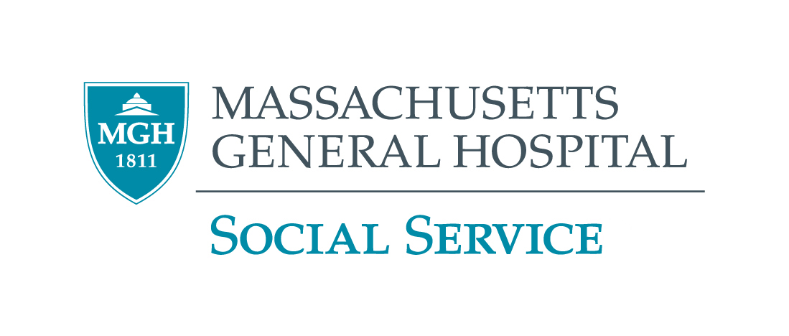

2024 – 2025 GRAND ROUNDS PROGRAM
MGH VIRTUAL EVENT

November 7,  2024  Thursday  10:00 – 11:30 a.m. | Taking a Look at Severe Mental Illness and Policy  Crystal Carrington, MSW, LICSW  Crystal Carrington is the Director for Adult Community Clinical Services at Bay Cove Human Services. Crystal also teaches at Boston University as an adjunct professor in the School of Social Work program, she has taught racial justice courses as well as courses on substance use. Crystal also owns and manages her own private practice which provides therapy in the areas of trauma, anxiety, depression, addictions, and service to BIPOC and LGBTQIA individuals.
November 14, 2024  Thursday  10:00 – 11:30 a.m. | Clinical Considerations, Challenges, and Strategic Innovations in the Treatment of Substance Use Disorders  Jennifer Blewett, DSW, LICSW, DCSW, CGP  Dr. Blewett is a Licensed Clinical Social Worker with over 18 years of experience in the provision of mental health and addiction treatment services. She serves as a clinician and social work supervisor in Psychiatry at Massachusetts General Hospital and has a private practice in Boston. Dr. Blewett also sits on the Massachusetts state board for the National Association of Social Workers and is a member of the Women in Leadership Committee at Massachusetts General Hospital.
December 12, 2024  Thursday  10:00 – 11:30 a.m. | Anarchist, Abolitionist, and Decolonial Perspectives for Social Work Practice  Carter J. Carter, Ph.D, MSW  Dr. Carter is Assistant Professor of Clinical Psychology at the Massachusetts College of Liberal Arts, he also serves as a Lecturer in the DSW program and is also Affiliated Faculty in the Program for Psychoanalytic Studies at the University of Pennsylvania. Dr. Carter also maintains a private practice with a specialty in psychoanalysis, psychotherapy, and clinical supervision. Dr. Carter serves as the lead labor organizer for the Massachusetts State College Association, the union for public university professors and librarians.
CEU’s Only available for Social Workers Call (617) 724-0759 for more information ALL STAFF WELCOME

