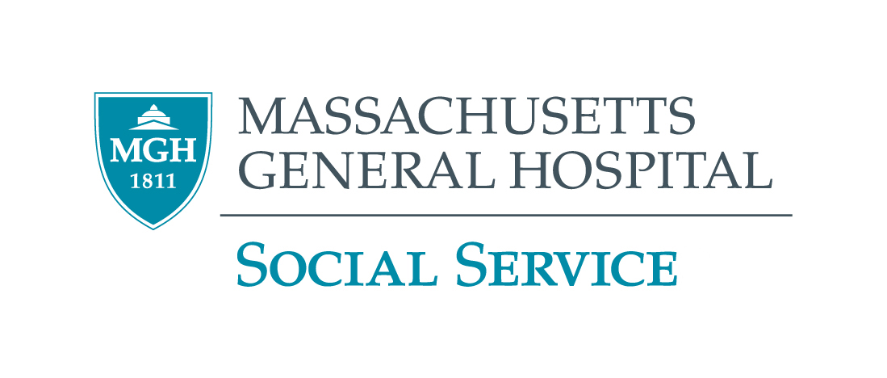

2024 – 2025 GRAND ROUNDS PROGRAM
MGH VIRTUAL EVENT

February 6,  2025  Thursday  10:00 – 11:30 a.m. | Chronic Pain Management  Gregory Acampora, M.D.  Dr. Acampora completed training in Anesthesiology at the University of Virginia as well as Yale for advanced Cardiovascular Anesthesiology. Dr. Acampora later became involved in physician health and treating addictions leading him to retrain in psychiatry. He is a Diplomat of the American Board of Neurology and Psychiatry and Addiction Psychiatry. He joined faculty at MGH in 2013 and is now the Assistant Professor of Psychiatry at Harvard Medical School.
February 13, 2025  Thursday  10:00 – 11:30 a.m. | Clinical Considerations, Challenges, and Strategic Innovations in the Treatment of Substance Use Disorders  Jennifer Blewett, DSW, LICSW, DCSW, CGP  Dr. Jennifer Blewett, DSW, LICSW, DCSW, CGP is a licensed clinical social worker with over 18 years of experience in the provision of mental health and addiction treatment services. She serves as a clinician and social work supervisor in psychiatry at Massachusetts General Hospital and has a private practice in Boston, Massachusetts. Dr. Blewett also sits on the Massachusetts state board for the National Association of Social Workers and is a member of the Women in Leadership Committee at Massachusetts General Hospital.
March 13, 2025  Thursday  10:00 – 11:30 a.m. | “I Had to Fix Me”: Discussing the Influence of Adverse Childhood Experiences and Behavioral Health Problems Among Social Workers and Other Helping Professionals  Jeffrey Steen, Ph.D, MSW  Jeffrey Steen is an Assistant Professor in the School of Social Work at Simmons University. At Simmons, he is overseeing several substance use-related projects, such as the school’s harm reduction training program, substance use coursework in the MSW program, and the University’s addictions studies initiative. As an LCSW he has provided substance use services in a variety of settings, including intensive outpatient programs, supportive housing, and private practice.
April 10, 2025  Thursday  10:00 – 11:30 a.m. | Social Work Practice in Outpatient Psychiatry  Sarah Gartaganis, MSW, MPH  Sarah Gartaganis, LICSW, MPH completed the dual degree Master’s program at Boston University School of Social Work and School of Public Health. Sarah spent many years in clinical research at the Marcus Institute for Aging Research at Hebrew Senior Life Research, most recently as a project director on multiple quality improvement initiatives and studies regarding delirium in hospitalized older adults.
May 8, 2025  Thursday  10:00 – 11:30 a.m. | Making and Breaking Links: Neoliberalism, Mass Incarceration and Carceral Logics in Social Work, and How We Might Resist Them  Elizabeth Kita  Elizabeth is a clinical social worker who obtained her MSW from UC Berkeley and PhD from Smith College and became interested in psychoanalysis when its ideas helped her to better understand her work in a state prison. In her private practice Beth works with people contending with complex trauma. Her practice in a public clinic has also focused on treating complex trauma, but solely with people who are incarcerated and formerly incarcerated, particularly those who’ve returned home after serving life sentences.
June 12, 2025  Thursday  10:00 – 11:30 a.m. | Trauma-Informed Care for Older Adult Populations  Monique Hedmann, M.D., MPH  Dr. Hedmann received her BA in Psychology from Emory University, her MPH as well as her Certificate in Premedical Sciences from Columbia University. While working at Columbia University Medical Center and Harlem Hospital Center she developed several public initiatives for older adults, children, and families in the NYC area. She also became a founding board member of Hip Hop Public Health, Inc and Arts & Minds, Inc. She attended medical school at Oregon Health and Science University and completed family medicine residency at Harbor-UCLA Medical Center, where she served as Regional Vice President for the Committee of Interns and Residents. She completed her fellowship in Geriatric Medicine at MGH and currently works in Adult Medicine and as a geriatrician at Baywell Health in Oakland, CA.
CEU’s Only available for Social Workers Call (617) 724-0759 for more information ALL STAFF WELCOME

