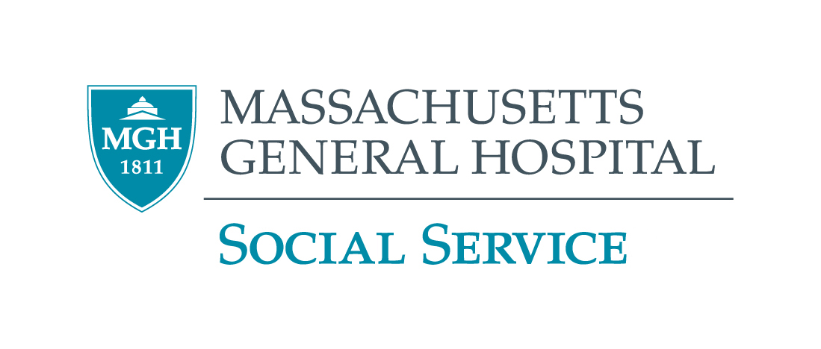

2023 – 2024 GRAND ROUNDS PROGRAM
MGH Virtual Event Until Further Notice

January 18, 2024  Thursday  10:00 – 11:30 a.m. | MGH Center for Immigrant Health, Best Practices  Fiona Danaher, M.D., MPH, Rahel Bosson, M.D., Rashmi Jasrasaria, M.D.  Dr. Danaher is the founding Director of the MGH Center for Immigrant Health, Chair of the MGH Immigrant Health Coalition, an instructor in Pedí at Harvard Medical School, and an Assistant Physician in Pedi at MGH. Dr. Bosson serves as an instructor in Psychiatry at Harvard Medical School, Medical Director of the Program Assertive Community Treatment at McLean Hospital, Associate Director of the Center of Immigrant Health at MGH and the Associate Program Director of the MGH/McLean Residency Program. Dr. Jasrasaria is a Primary Care Physician in the Adult Medicine Unit at MGH Chelsea HealthCare Center, Associate Director of the MGH Center for Immigrant Health, an Ambulatory Core Educator within the MGH Department of Medicine Residency Program, and an instructor in Medicine at Harvard Medical School.
February 15, 2024  Thursday  10:00 – 11:30 a.m. | Mass General Brigham Equity and Community Health Policy Priorities  Debra Drumm, MSW, LICSW, Sandra Elien, BA  Debra Drumm has been the Director of the MGH HAVEN/VIAP programs for the past 8 years, Debra is also the Clinical Leader responsible for Social Workers in the Emergency Department and Blake 11. Sandra Elien has been a Domestic Violence advocate for over 30 years, Sandra joined the MGH HAVEN program in 2003 as one of the first bilingual/bicultural domestic violence advocates where she continues to provide trauma-informed, strength-based counseling, advocacy, trainings, provider consults and support group facilitations.
March 21, 2024  Thursday  10:00 – 11:30 a.m. | What is Gender-Affirming Care?  Kit Rainboth, MSW, LICSW, Jennifer Siegel, M.D.  Kit is a Licensed Independent Clinical Social Worker at the MGH Transgender Health Program, Kit provides connections to community-based resources and programs that support the gender affirmation journey. Dr. Jennifer Siegel is a Primary Care Physician and Medical Director of the MGH Transgender Health Program.
April 18, 2024  Thursday  10:00 – 11:30 a.m. | Secondary Traumatic Stress; The Invisible Occupational Hazard  Mary Susan Convery, MSW, LICSW  Mary Susan Convery is the Social Services OB Clinical Leader at MGH. Mary Susan has been at MGH for 19 years.
May 16, 2024  Thursday  10:00 – 11:30 a.m. | At the End of Things: Spirituality and Collective Care in the Face of Death  Jennifer Bailey, MDiv, BA,  Rev. Jen Bailey is an ordained minister, public theologian, and a national leader in the multi-faith movement for justice. Jennifer is the Founder and Executive Director of Faith Matters Network.
June 20, 2024  Thursday  10:00 – 11:30 a.m | QPR: Question, Persuade & Refer: Suicide Prevention Program  Deborah Helms, AS  Deborah Helms is the Director of Samaritans of Merrimack Valley a program of Family Services of the Merrimack Valley.
CEU’s Only available for Social Workers Call (617) 724-0759 for more information ALL STAFF WELCOME

