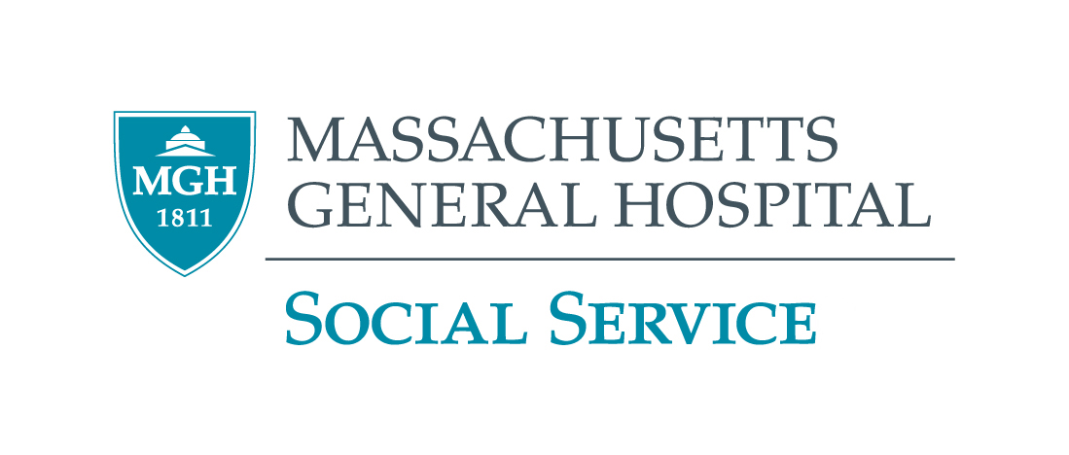

2025 GRAND ROUNDS PROGRAM
MGH VIRTUAL EVENT

October 9,  2025  Thursday  10:00 – 11:30 a.m. | Reproductive Justice and Social Work: Navigating Insurgent Practice in Sociopolitical Context  Kristen Ethier, MSW, Ph.D.  Kristen L. Ethier, LCSW, PhD, is an Assistant Professor at Simmons University School of Social Work. The aim of Dr. Ethier's work is to transform individual lives, interventions, and systems towards a vision of reproductive justice and family thriving. As an intersectional feminist social worker, her teaching, practice, and scholarly work have long been devoted to promoting sexual and reproductive health equity across several populations and promoting family thriving for parents and their children who experience oppression.
December 4, 2025  Thursday  10:00 – 11:30 a.m. | On Being a Good Social Worker in Bad Times  Carter J. Carter, MSW, Ph.D.  Dr. Carter is Assistant Professor of Clinical Psychology at the Massachusetts College of Liberal Arts, he also serves as a Lecturer in the DSW program and is also Affiliated Faculty in the Program for Psychoanalytic Studies at the University of Pennsylvania. Dr. Carter also maintains a private practice with a specialty in psychoanalysis, psychotherapy, and clinical supervision. Dr. Carter serves as the lead labor organizer for the Massachusetts State College Association, the union for public university professors and librarians.
December 11, 2025  Thursday  10:00 – 11:30 a.m. | Responding to Neighbors With HEART  Abena Bediako, MSW, LCSW, LCASA  Abena’s first-hand experiences have shaped her philosophy that we all have the innate ability to heal ourselves, by viewing herself as a conduit to healing as a licensed clinical social worker. Abena currently serves as Clinical Manager with the Durham Community Safety Department. In this role, she serves as a thought leader and change maker to ensure folks in the community receive the most appropriate care whilst in the midst of a crisis. Abena has provided clinical services to children, adolescents, and adults in multiple settings.
CEU’s Only available for Social Workers Call (617) 724-0759 for more information ALL STAFF WELCOME

