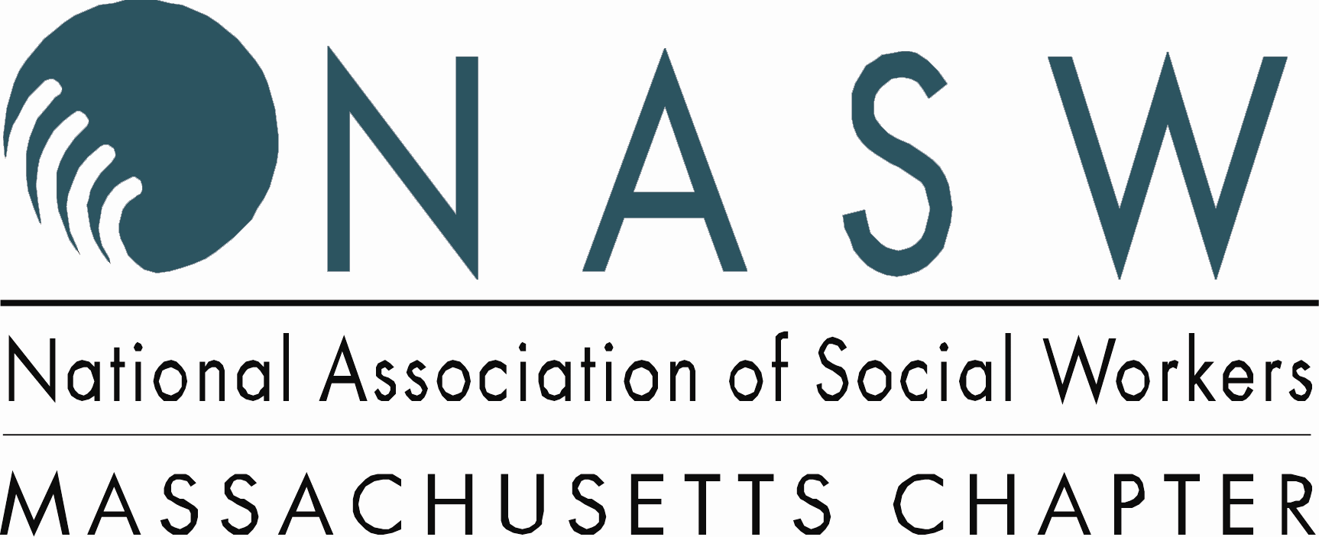

FACT SHEET
Updated: July 13, 2010

HB 3465 now HB4681: An Act Improving Emergency Access to Mental Health Services

2009-2010 Legislative Session NASW Priority

Lead Sponsors: Rep. David Sullivan
PASSED IN THE HOUSE JULY 6, 2010

Background
Currently, Massachusetts general law Chapter 123 Section 12 states that the emergency hospitalization and examination of persons in imminent danger of causing harm to themselves or someone else, may only be authorized by physicians, psychologists, psychiatric nurse mental health clinical specialists and police officers. An Act to Improve Emergency Access to Mental Health Services would include LICSW’s to this law as qualified mental health professionals who could issue a “Section 12”.
In addition, LICSW’s would be added to Massachusetts General Law Section 22, joining physicians, psychologists, psychiatric nurse mental health clinical specialists and police officers with immunity from civil suits resulting in the authorization of a “Section 12”.
Why this legislation is important
Currently, social workers in various settings are charged with assessing clients who are experiencing a mental health crisis such as suicidal or homicidal ideation. However, social workers do not have the authority to issue a “Section 12”.

LICSW’s are master’s level clinicians trained to determine when clients are a danger to themselves or to others. As it stands today, social workers must have their assessment of a client in acute mental distress approved by a physician, psychologist, nurse or police officer in order for their patient to receive the emergency treatment they need, which can delay treatment in sometimes life threatening situations. Similar to the majority of the states in the nation, this legislation would authorize social workers in Massachusetts to effectively protect their clients as well as the general public.

For more information contact
Rebekah Gewirtz, NASW Director of Government Relations and Political Action 617.227.9635 x12 gewirtz@naswma.org or Kathryn Audette, NASW Government Relations and Political Action Associate 617.227.9635 x20, Audette@naswma.org

