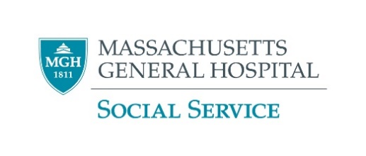

Local Individual Shelters that Accept Self-Referrals

We understand that you are not interested in going to shelter at this time. Please feel free to contact your social worker if that changes while you are here - we'd be happy to refer. Here are some local shelters that accept self-referrals in case that may be helpful in future.

Please note the information below is subject to change. Please contact the shelter directly to confirm.

Shelters for Men
- Southampton St. Shelter
112 Southampton St. Boston, MA 02118, 617-534-6100
How to Sign-up/Time to Arrive: Call the triage line at (617) 534-4440 or arrive at shelter to self-refer.

- Pine Street Inn – Men’s Unit
444 Harrison Ave. Boston, MA 02118, 617-892-9228
How to Sign-up/Time to Arrive: Triage begins at 11:00AM and goes until 6:30PM daily. Beds are given on a first come first serve basis.

- Bristol Lodge Shelter
27 Lexington St., Waltham, 781-893-0108
How to Sign-up/Time to Arrive: No walk-in clients. You can call M-F beginning at 9:00AM until 2:00PM and will be notified if a bed is available.

Shelters for Women
- Rosie’s Place
889 Harrison Ave. Boston, MA 02118
(617) 442-9322
How to Sign-up/Time to Arrive: Call (617) 442-9322 to see when the next bed lottery is taking place. Lotteries take place in person.

- Bristol Lodge Shelter
205 Bacon St. Waltham, MA 02452 781-893-0108
How to Sign-up/Time to Arrive: No walk-in clients. You can call M-F beginning at 9:00AM until 2:00PM and will be notified if a bed is available.

- Woods Mullen Shelter
794 Mass Ave. Boston, MA 02118, 617-534-7100
How to Sign-up/Time to Arrive: Call the triage line at 617- 534-4440 or go to the shelter to self-refer.

- Pine Street Inn -Women’s Inn
363 Albany Street Boston, MA 02118
617-892-9228
How to Sign-up/Time to Arrive: Tirage begins at 11:00AM and goes until 6:30PM daily. Beds are given on a first come first serve basis.

Shelters for Youth
- Youth 18-24: Y2Y Youth Shelter
1 Church St. Cambridge, MA 02138
How to Sign-up/Time to Arrive:
Online: You can fill out this form: https://www.tfaforms.com/4638535 before 8:00AM to be considered for the current night or after 8:00AM to be considered for the following night. If you sign-up online you will be notified of your lottery results via email by 9:15AM.
By Phone: You can call (617) 864-0795 between 8:00AM-8:30AM on the days you want to enter the lottery. You will receive a lottery number and need to call back between 8:45AM-9:15AM to learn if your number was selected. Results are also posted on the shelter door.
  - Service providers can submit entry form on behalf of a client: https://www.tfaforms.com/4638535
  - More info: y2ynetwork.org/beds/

- Youths 18-24: Bridge over Troubled Waters
47 West St. Boston, MA 02111, 617-423-9575
Individuals can walk-in for an intake from 9:00AM-4:00PM; Once an intake is completed, they can enter the lottery.

