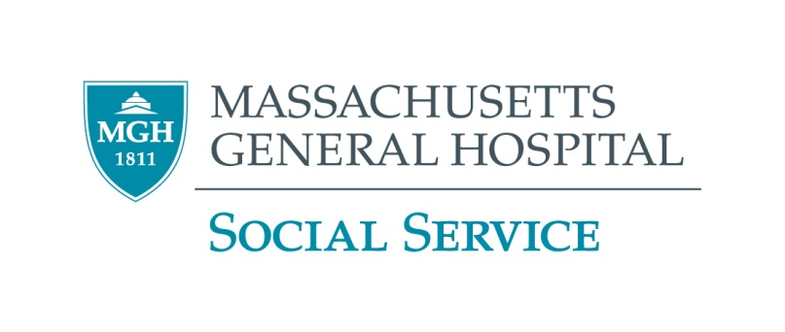**Acillary Relief**

**Policy and Procedure**

**PURPOSE**

To provide “emergency” financial assistance (usually one time only) to patients when they have no other means.

**POLICY**

The Social Service Department will manage special funds to be used for patients’ ancillary needs. Ultimate decision on approval and designation of fund is made through the Administrative Office of Social Service. Patients who are MGH or Partners Institution Employees and are in need of financial relief should contact their Employee Assistance Program.

**PROCEDURE**

Prior to requesting Ancillary Relief the social worker should seek other sources for relief such as the patient’s family or other agencies.

An Ancillary Relief Form must be filled out by the social worker, signed and submitted to the Administrative Office care of **Anaceilys Sanchez**. Requests for lodging are to be completed on the Lodging Program Ancillary Request form and faxed directly to Beacon House or MGH at the Inn. Social worker is to call the lodging facility to confirm receipt of fax.

If the Ancillary Relief is to pay for a product/service, the vendor must submit a bill to **Anaceilys Sanchez**.

**PETTY CASH**

Funds for petty cash for patients’ emergency needs are limited therefore cannot exceed $15.00. The social worker must call **Anaceilys Sanchez (ex. 6-2605)** to make the request.

**ANCILLARY NEEDS COVERED** include, but are not limited to:

• Basic need

• Camp

• Transportation

• Emergency Lodging

• Travel – local