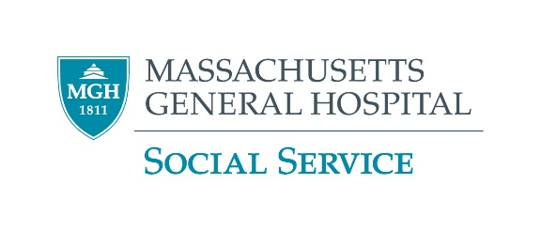

**Find Therapy for Your Child**

**The First Steps**

Start with your insurance. Call the number on the back of your card (there may be a number for “behavioral health”). Ask about any special rules you must follow, such as getting a referral or using certain providers. Then use the list below as appropriate.

**Does your child have MassHealth?** If so, start with the **Children’s Behavioral Health Initiative (CBHI)**. Some services you may refer your child to directly, and some require a referral from your child’s doctor or other health provider.

**Ask Your Doctor (or Other Health Provider) to Refer**

* **Massachusetts Child Psychiatry Access Program (MCPAP)**

MCPAP improves access to treatment for children with behavioral health needs and their families by making child psychiatry **services accessible to primary care providers** across Massachusetts. MCPAP is available for all children and families, through their primary care providers, regardless of insurance.

Western & Central Mass Team: 844-926-2727  
Eastern Mass Team; Boston South: 844-636-2727  
Eastern Mass Team; Boston North (MGH): 855-627-2763

**Mass General Programs**

* **Mass General Child Cognitive Behavior Therapy (CBT) Program**

The CBT Program delivers short-term, problem-focused, skills-based therapy to patients ages 3-24, with a variety of issues, including anxiety, depression, ADHD and other difficulties.

Complete an intake form here. After you submit the form, a representative will call you back or call 617-643-9898, Monday–Friday, 8:30 am to 5:00 pm.

* **Salem Hospital Child and Adolescent Psychiatry**

Part of the Mass General Brigham network, Salem Hospital offers a safe haven for children and adolescents with depression, anxiety, psychiatric disorders, post-traumatic stress disorders, and other behavioral problems. See the website: Child and Adolescent Psychiatry or call 978-354-2700.

* **Mass General Benson-Henry Institute, Resilient Youth Virtual Group**

Drawing from well-established, evidence-based interventions to manage stress and build resilience in children and adolescents, the MGH Benson-Henry Institute for Mind Body Medicine is offering Resilient Youth workshops to youth.  Scholarships are available to waive the small fee. See the website: Resilient Youth or call 617-643-6090

**Community Mental Health Centers – May offer free or reduced- cost care**

* **Riverside Community Care**

Locations in Lynnfield, Milford, Newton, Norwood and Somerville. See the website: Riverside Community Care or call 781-329-0909.

* **South Bay Mental Health**

More than 20 locations including Brockton, Chelsea, Dorchester, Framingham, Lynn, Lowell, Springfield and Worcester. See all locations. More information on the website:

South Bay Community Services. Phone numbers on the locations page.

* **Eliot Community Human Services**

See the website: Eliot Community Human Service, complete the Referral for Services form or call 781-861-0890. Locations vary by service - see the referral services form for details.

**Therapy Finders**

These listings are provided as a convenience for our patients and their families. This list is not comprehensive. **Mass General Hospital does not endorse any non-Mass General affiliated facilities.**

* **Social Work Therapy Referral Service**

Speak directly to a social worker who will assist in locating 2-3 therapists who are accepting new clients and have experience working with your identified problem.  
http://www.therapymatcher.org/ or call 617-720-2828

* **Psychology Today**

Helps find therapist, psychiatrist, or support groups according to location, gender, insurance, specialty, religious orientation, age group, language, and treatment orientation.

Psychology Today - Find a Therapist

* **William James INTERFACE Referral Service**

See if your community participates: https://interface.williamjames.edu/, then call 888-244-6843(toll free); 617-332-3666 (local) Mon – Fri, 9am – 5pm

* **Goodtherapy.org**

Helps find therapist according to location, specialty, age group, insurance. http://www.goodtherapy.org/

* **Thriveworks** (does NOT accept Mass Health) – Boston area Onsite & Online Counseling in Boston
* **LifeStance Health** (formerly Child & Family Psychological Services)

Eastern MA locations: [Child & Family Psychological Services - find a location](https://www.cfpsych.org/)

bl 7/21